**Chapter three**

**Research methodology**

**Introduction**

This chapter entails the methodology adopted in developing the proposed Budget Blockchain Management System for Nigeria budget appraisal, the use case diagram, conceptual design, Budget flow diagram using blockchain technology and flowchart illustration of the proposed system. finally, the overall budget and blockchain approach is comprehensively explain in this chapter.

**Feature of the proposed system**

1. Decentralize, secure Budget management system for auditing Nigeria Budget Transactions.
2. Distributed, Immutable, and time-stamped ledger system for Nigeria Budget using Blockchain Technology.
3. A web-based management system using Django web framework (Backend development framework), Bootstraps (Frontend development framework) and Postgres Database (to store and manage user, transaction and blockchain records)
4. Interfaces for registration, signing in, initiating transaction, checking account details, and viewing transaction history.
5. Budget Funds can be send or received using a unique primary key associated to an individual.

**Conceptual Design of the Overall System**

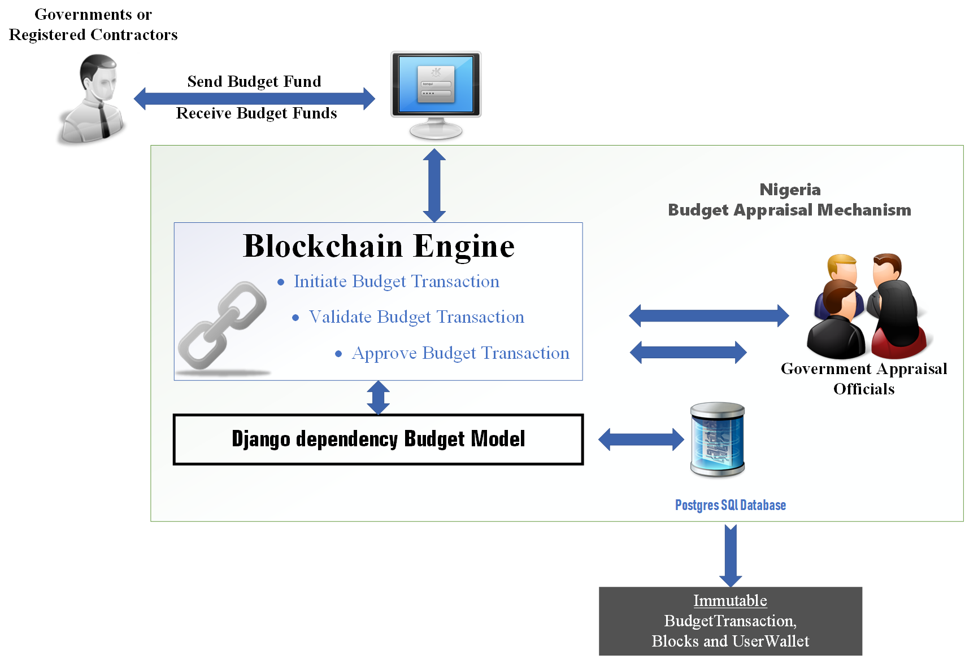The conceptual design illustrates the architectural design of the proposed system. by visually denoting important entities and adopted technology for the proposed system.

**Fig 3.1 Conceptual framework of the Budget Blockchain Management System**

The proposed system in Fig 3.1 includes various entities such as Government official, registered contractors, user interface, Government Appraisal Officials and the likes.

**Governments Officials or Registered Contractor**

the Government official are personal involve directly in receiving or transferring Budget funds to other official, the include the accountant general of Nigeria federation, Governors, Senators, house representative, local government chairman and the likes. This bodies might also include registered external contractors, which are contracted for building government infrastructure such as road, hospitals, dams, schools, power station, and lots more. The Nigeria government official or registered contractors can interact with the proposed system via the user interface.

**Graphical User Interface**

The graphical user interface enable interaction between the end users and the internal functionality of the proposed system. the user interface includes

1. Registration page for registering new government official or external contractors.
2. Sign up page for signing into the system using valid credentials provided during registration
3. Home page for both registered and non-registered users, for viewing transaction history of budget funds.
4. Wallet or Account page for showing each registered user information such as is full name, fund balance, transaction history and other more.

**The Blockchain Engine**

The blockchain engine comprises of the blockchain technology for managing Nigeria Budget funds transactions. The engine automates transaction process and group multiple tractions within a block, each block is mined and chain with the previous block using their hash value. Transaction stored on the chain can be easily monitored, validate by the consensus of Government officials. The blockchain technology provide functionalities such as security, Distributed, decentralize, immutable transaction, time-stamp and transparent Budget Management System.

**Django Dependency Budget Models**

The Django framework is a python programming language framework for web development. The Django framework is used to developed the Nigerian Budget Models (Budget Transactions, Budget Blocks and Users). The Django framework helps in performing various functionalities such as;

1. Connecting with the servers for rendering web pages
2. Database communication for storing and retrieving Budget transactions or budget block information.

**Budget Appraisal Officials**

This are group of officials that uses the blockchain technology to approve, validate and monitor budget Transaction between government officials or registered contractors. They ensure every Budget transaction is distributed and allocated for the intended purpose. In addition, they also ensure that Transaction are not approved for projects that are not approved yet.

**Postgres SQL database**

The PostgreSQL database technology is the world’s most advance open source DBMS, supporting the vast majority of SQL transaction, concurrent control, and modern features such as complex queries, triggers, views, transaction integrity and the capability to add data type extension (Viloria et al., 2019). The propose architecture adopt the PostgreSQL database to store immutable budget transaction, blocks and user information.

**Budget Flow using Blockchain technology**

The fig 3.1 indicates the major transaction procedural step of exchange of Budget funds among Government officials or Government Registered Contractors.

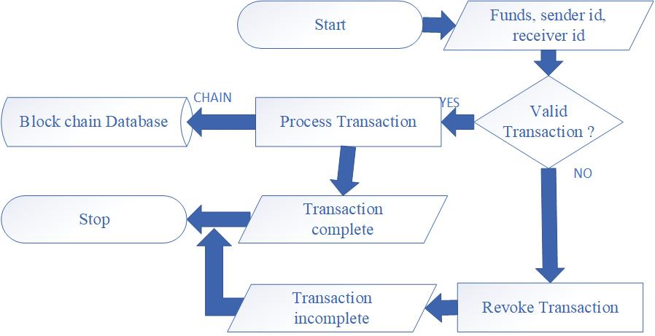

**Fig 3.2 the propose system flow chart illustration**

However, the diagram indicate dataflow using directional arrows and action perform at every stage using various geometric shapes. Each stage of the fig 3.2 is explained as follows;

1. **Start**: indicating the starting or initialization point of the flowchart diagram, which is diagrammatically depicted using the oval shape.
2. **Budget Funds, Sender, and Receiver id**: At this stage the process received Fund value, sender and receiver id as input. the budget fund is the momentary value been exchange or distributed to the appropriate government official or external contractors. Sender and receiver id is the public key associated with all the register users of the system. the Id’s enable sender to specify account address of the recipients.
3. **Valid Transaction:** This step is a conditional statement, checking if the transaction initiated is valid or not. Valid transactions are made up of valid recipient address, sufficient sender fund balance and the likes. At this stage the data flow is splitter into two ‘Yes’ for valid transaction and ‘No’ for non-valid transaction.
4. **Process Transaction:** this step is executed if the transaction process is valid
5. **Revoke Transaction:** the revoke transaction is activated only if the transaction is non-valid
6. **Blockchain Database:** this only stores valid transaction in groups as a block and chain each block to the previous block using cryptography.
7. **Complete or incomplete Transaction:** this step either output ‘complete transaction’ for valid transactions, and ‘incomplete transaction’ for invalid transaction.
8. **Stop:** indicating the end of the flow chart process.

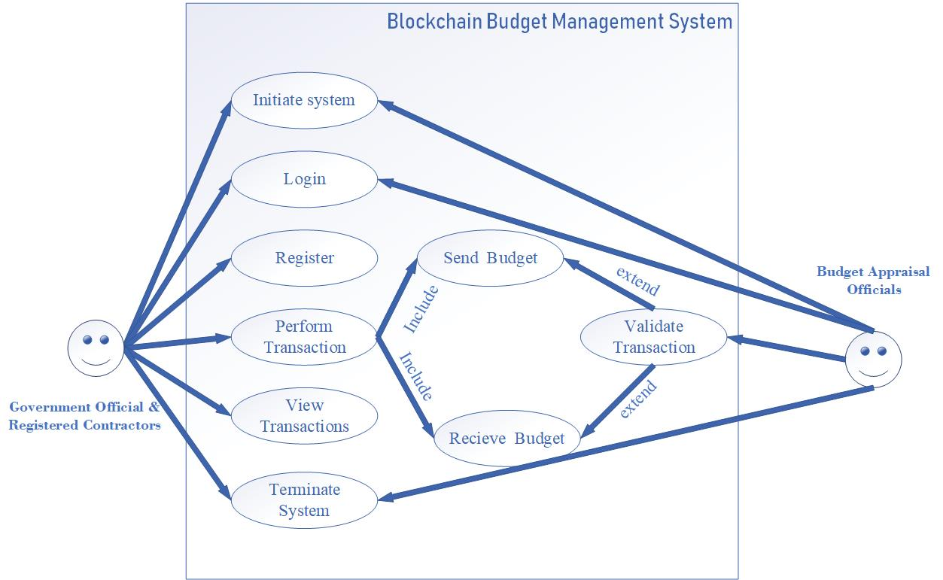**System use cased illustration**

**Fig 3.3 the use case diagram of the propose system**

The use case diagram describes the actors or users in the system, and the functionality they can perform. Bases on the fig 3.3 they are two major set of actors, the first set includes Government officials or Registered Contractor, while the second set entails the group of governmental bodies performing auditing, validation and approving transactions on the system.

**Government Official & Registered Contractors**

* They can initial the system
* Login into the system
* They can perform registration
* They can View Transaction
* Perform Transaction
* Send Budget Funds to a public address
* They can receive Budget funds from any officials or registered contractor
* Can Terminate the System

**Budget Government Appraisal Officials**

* They can initiate the system
* They can view Transaction
* Validate Transaction
* They can terminate the system

**Budget Blockchain Management System Proposed framework**

This section illustrates the adopted approach in a comprehensive manner, with diagrams and textual explanation of the proposed system. the proposed system comprises of four stages this includes; MTEF/FSP, budget Preparation, Budget Approval, Budget Implementation and finally 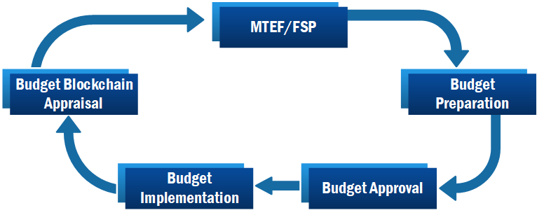Budget Blockchain Appraisal. The fig 3.4 diagrammatically illustrate the proposed Blockchain Budget management proposed framework.

**Fig 3.4 the propose blockchain budget Management Framework**

The fig 3.4 showing the stages (MTEF/FSP, budget preparation, budget Approval, budget Implementation and budget blockchain appraisal) is diligently explained bellow.

**MTEF/FSP Document**

The Medium-Term Expenditure Framework and the Fiscal Strategy Paper document contain information about the back revenue and preparation of estimated budget or revenue with Nigeria expenditure. At this stage the estimate public expenditure of compositional distribution and basic for sectorial are provided. The MTEF and FSP point out the microeconomic framework that specifies the fiscal targets, estimated revenues, expenditures and the underlying assumption for these projections. Additionally, it provides the foundation for annual budget planning.

**Budget Preparation:**

Budget Preparation stage come after the legislature has accepted the MTEF and FSP documents, this stage starts by accessing the previous year’s budget performance. As a result, data is collected and analyzed while taking into consideration political, economic and societal constrains. The Government Ministries, Departments, and Agencies (MDAs) provide their intended expenditures and expected revenue within the fiscal year’s ceiling, as well as their special needs and contingency projection, which are consolidated by the budget units of the individual MDAs.

**Budget Approval**

Moreover, after the budget planning stage, the president formally presents the draft budget (also known as the Appropriation Bill) to the legislature for approval as required by law. The National Assembly's responsibility is to conduct a first and second reading of the Appropriation Bill. Only the short title of the Bill is read at the first reading, while the general principles of the Bill are debated by politicians in both houses of the National Assembly during the second reading. After then, the bill is referred to appropriate committees for further legislative consideration.

**Budget Implementation**

Once the budget is approved, The Federal Ministry of Finance issues a warrant to the Accountant General of the Federation to release funds from the consolidated revenue, to cover the budgeted services that are approve in the estimates. The warrant allows the MDAs to spend money that has been granted in the estimates. This is the stage in which the budget's operations are carried out and implemented.

**Budget Blockchain Appraisal**

Traditionally, the budget appraisal employed traditional approach in controlling the disbursed funds to the appropriate or intended purpose. The traditional method also includes budget monitoring to ensure that money is spent wisely and efficiently. Additionally, it also ensures that financial commitments and expenditures do not exceed the approved amounts. However, in this sturdy the budget appraisal stage is integrated with blockchain technology to digitalize the traditional functionality and improve on the existing mechanisms based on speed, security, transparency, decentralized, efficient tracking and auditing. The diagram below illustrates the integration of blockchain with Traditional budget Appraisal.

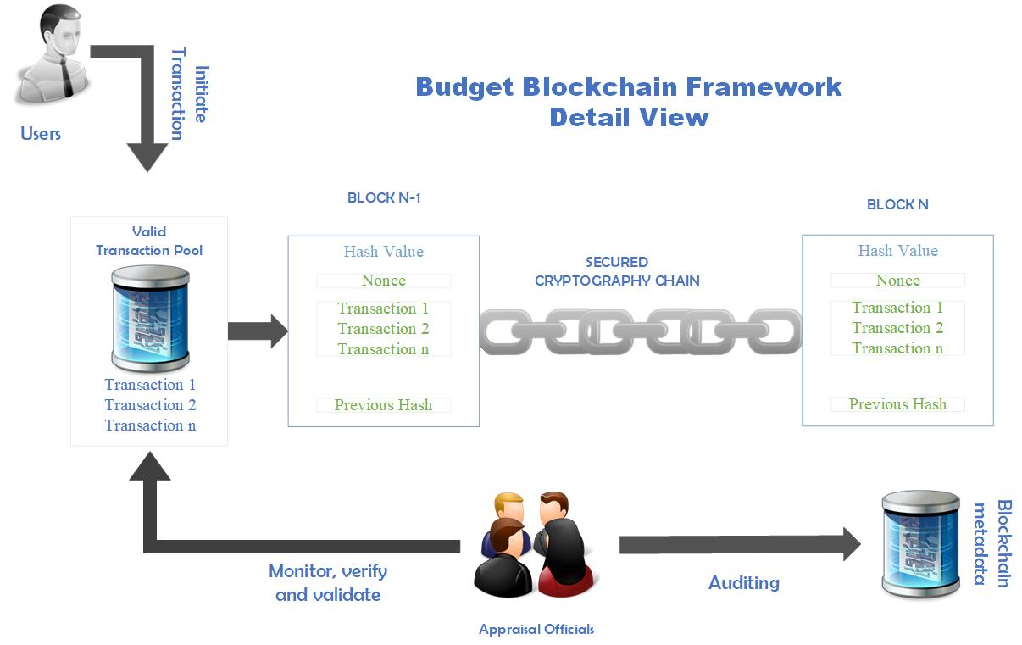

**Fig 3.5 Budget Blockchain integration.**

The fig 3.5 in detail illustrate the digitization of budget appraisal stage using blockchain technology, the help in managing, tracking, auditing, and monitoring disbursed budget funds. In addition, the technology also provides, secure, unmodifiable, transparent and decentralize budget transaction records. Considering fig 3.4, transaction can be initiated by users and the valid transactions are accumulated in the transaction pool. As illustrated, block is chained together using cryptography mechanism, and each block holds information such as the Hash Value, Nonce, Group of Valid Transaction, and Previous Block Hash. Furthermore, the Appraisal Official can easily perform auditing (keep records or account), and verification of transactions with the help of blockchain mechanisms.

**Reference**

Viloria, A., Acuña, G. C., Franco, D. J. A., Hernández-Palma, H., Fuentes, J. P., & Rambal, E. P. (2019). Integration of data mining techniques to postgresQL database manager system. *Procedia Computer Science*, *155*(2018), 575–580. https://doi.org/10.1016/j.procs.2019.08.080